Stairways of Walking-Working Surfaces Training Material and Comprehension Quiz

- Policy
  - Romero’s Food Products Inc. minimizes the hazard of stairway accidents as these are designed and built-in by the Occupational Safety and Health Standards.

- Procedure
  - General requirements
    - Handrails, stair rail systems, and guardrail systems are provided.
    - Vertical clearance above any stair tread to an overhead obstruction is at least 6 feet, 8 inches (203 cm), as measured from the tread's leading edge. Ensure spiral stairs must meet the vertical clearance requirements.
    - Stairs have uniform riser heights and tread depths between landings.
    - Stairway landings and platforms are at least the widths of the stair and at least 30 inches (76 cm) in depth, as measured in the direction of travel.
    - When a door or a gate opens directly on a stairway, a platform is provided, and the swing of the door or gate does not reduce the platform's effective usable depth to:
      - Less than 20 inches (51 cm) for platforms installed before January 17, 2017; and
      - Less than 22 inches (56 cm) for platforms installed on or after January 17, 2017 (see Figure D-7 of this section)
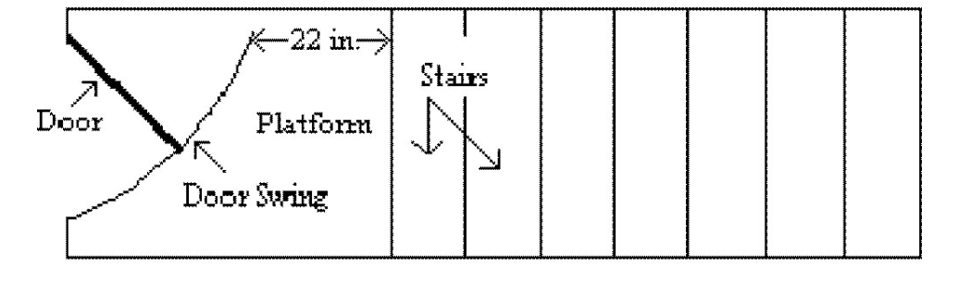

Figure D-7 – Door or Gate Opening on Stairway
    - Each stair can support at least five times the normal anticipated live load but never less than a concentrated load of 1,000 pounds (454 kg) applied at any point.
    - Standard stairs provide access from one walking-working surface to another when operations necessitate regular and routine travel between levels.
    - Spiral, ship, or alternating tread-type stairs are used only when the employer can demonstrate that it is not feasible to provide standard stairs.
    - When allowing the use of spiral, ship, or alternating tread type, ensure it is installed, used, and maintained according to the manufacturer’s instructions.
  - Standard stairs
    - Are installed at angles between 30 to 50 degrees from the horizontal;
    - Have a maximum riser height of 9.5 inches (24 cm).
    - Have a minimum tread depth of 9.5 inches (24 cm); and
    - Have a minimum width of 22 inches (56 cm) between vertical barriers. (See Figure D-8 of this section).

.

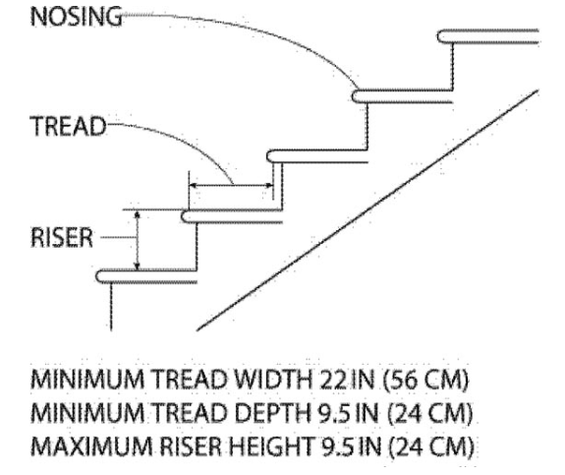

Figure D-8 – Dimensions of Standard Stairs
    - Exception:
      - The maximum riser height and minimum tread depth do not apply to standard stairs installed before January 17, 2017. OSHA will deem those stairs in compliance if they meet the dimension requirements specified in Table D-1 of this section or use a combination that achieves the angle requirements.
Angle to horizontal Rise (in inches) Tread run (in inches)
30 deg. 35' 6 1/2 11
32 deg. 08' 6 3/4 10 3/4
33 deg. 41' 7 10 1/2
35 deg. 16' 7 1/4 10 1/4
36 deg. 52' 7 1/2 10
38 deg. 29' 7 3/4 9 3/4
40 deg. 08' 8 9 1/2
41 deg. 44' 8 1/4 9 1/4
43 deg. 22' 8 1/2 9
45 deg. 00' 8 3/4 8 3/4
46 deg. 38' 9 8 1/2
48 deg. 16' 9 1/4 8 1/4
49 deg. 54' 9 1/2 8

Table D-1 - Stairway Rise and Tread Dimensions
  - Spiral stairs
    - Have a minimum clear width of 26 inches (66 cm);
    - Have a maximum riser height of 9.5 inches (24 cm);
    - Have a minimum headroom above spiral stair treads of at least 6 feet, 6 inches (2 m), measured from the leading edge of the tread;
    - Have a minimum tread depth of 7.5 inches (19 cm), measured at a point 12 inches (30 cm) from the narrower edge;
    - Have a uniform tread size.
  - Ship stairs
    - Are installed at a slope of 50 to 70 degrees from the horizontal;
    - Have open risers with a vertical rise between tread surfaces of 6.5 to 12 inches (17 to 30 cm);
    - Have a minimum tread depth of 4 inches (10 cm); and
    - Have a minimum tread width of 18 inches (46 cm).

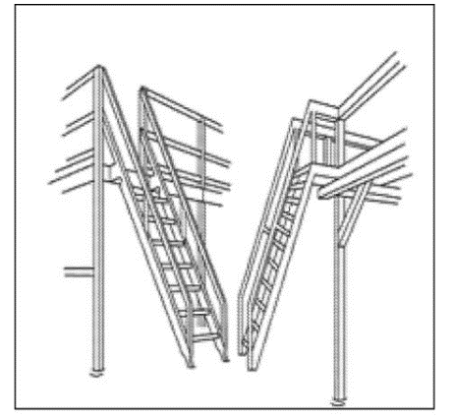

Figure D-9 – Ship Stairs
  - Alternating tread-type stairs
    - Have a series of treads installed at a slope of 50 to 70 degrees from the horizontal.
    - Have a distance between handrails of 17 to 24 inches (51 to 61 cm);
    - Have a minimum tread depth of 8.5 inches (22 cm);
    - Have open risers if the tread depth is less than 9.5 inches (24 cm); and
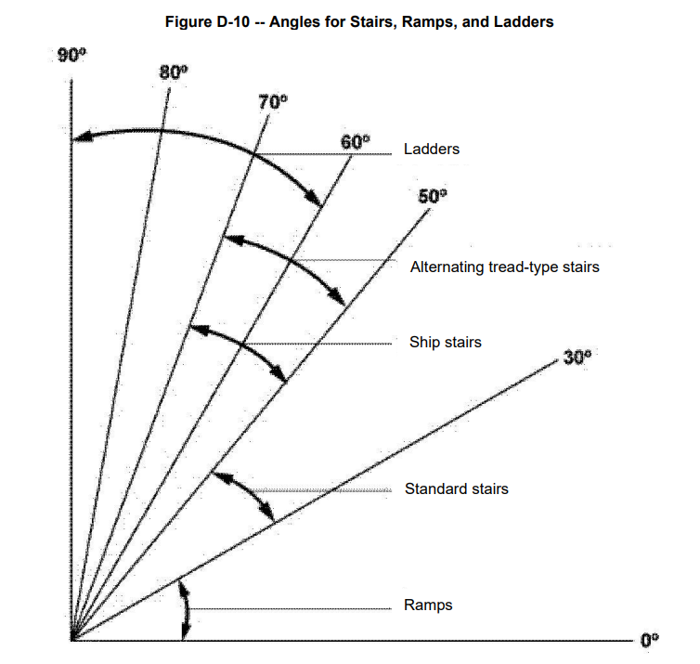
    - Have a minimum tread width of 7 inches (18 cm), measured at the tread's leading edge (i.e., nosing).

Angle | Type
≤30° | Ramps
30°-50° | Standard Stairs
50°-70° | Ship Stairs
50°-70° | Alternating Thread-Type Stairs
60°-90° | Ladders

Figure D-10-Angles for Stairs, Ramps, and Ladders

- Responsibility
  - Department managers are responsible for identifying any existing or potential hazards and for identifying which employees require training before working on stairs.
  - Supervisors must provide stairways required for working in hazardous situations.
  - Employees are responsible for following the procedure specified in this policy.
    - Employees are responsible for the proper care, use, and inspection of stairways as assigned
    - Employees are expected to report any unsafe conditions to a supervisor.

- Corrective Action
  - Once a potential hazard is identified, the employee must report the unsafe conditions and be trained accordingly.

- Review – Quality
  - Review the general requirements for the development of rules and regulations.
  - Confirm that the general requirements comply with the standards.
  - A review of these general requirements is conducted periodically.

- History
Revision No.: | Revision Date: | Description of Change: | Originator / Author Name: | Title / Department:
0 | 20220902 | Original | Arnel Ryan | PCQI / Compliance
1 | 20231206 | - Aligned with the updated program.  - Updated the Procedure and Comprehension Quiz.  - Added Comprehension Quiz: ANSWER KEY. | Arnel Ryan | PCQI / Compliance
2 | 20241003 | - Change title prat from Lesson to Training Material and Comprehension Quiz.  - Change Review to Review-Quality.  - Change email from rfp@interlinkiq.com to rfp@consultareinc.com | Arnel Ryan | PCQI / Compliance

Requirements:
- The trainee has read or received a verbal translation of all or part of the policy, procedure, method, and or SOP for which they are being trained.
- The trainee has demonstrated the task they are to perform or the procedure for which they are being trained as required.
- The trainee has demonstrated the ability to perform the task with acceptable proficiency and with minimal supervision as required.

TRAINEE (Print Name): | TRAINEE (Signature): | Date: | Department:
Trainer / Supervisor (Print Name): | Trainer (Signature): | Date: | Department:

UPON COMPLETION – EMAIL TO rfp@consultareinc.com

NAME (Print): | Date:

Stairways of Walking-Working Surfaces Comprehension Quiz

Direction: Choose the best answer and encircle the letter.

- Each stair can support at least five times the normal anticipated live load, but never less than a concentrated load of ___________ applied at any point.
  - 2000 Pounds
  - 1000 Pounds
  - 3000 Pounds

- Spiral stairs have a minimum headroom above treads of at least _______, _______measured from the leading edge of the tread.
  - 7.5 Inches, 12 Inches
  - 6 Inches, 8 Inches
  - 6 Feet, 6 Inches

- Who is responsible for providing stairways required for working in hazardous situations?
  - Department Managers
  - Supervisors
  - Employee

- Ship stairs have a minimum tread depth of _______ and ________ minimum tread width of 18 inches.
  - 4 Inches, 18 Inches
  - 7.5 Inches, 12 Inches
  - 6 Inches, 8 Inches

- What are the minimum tread depth and minimum width for standard stairs?
  - 9.5 Inches, 22 Inches
  - 8.5 Inches, 7 Inches
  - 6 Feet, 6 Inches

UPON COMPLETION – EMAIL TO rfp@consultareinc.com

